Tanzania

## Political Stability Estimate Data

The data set shows the political stability estimate of the country each year.

## # A tibble: 19 x 5  
## country iso3c date stability stabilityCategory4   
## <chr> <chr> <dbl> <dbl> <chr>   
## 1 Tanzania TZA 1996 -0.624 moderately unstable  
## 2 Tanzania TZA 1998 -0.406 moderately unstable  
## 3 Tanzania TZA 2000 -0.702 moderately unstable  
## 4 Tanzania TZA 2002 -0.252 moderately unstable  
## 5 Tanzania TZA 2003 -0.854 moderately unstable  
## 6 Tanzania TZA 2004 -0.671 moderately unstable  
## 7 Tanzania TZA 2005 -0.583 moderately unstable  
## 8 Tanzania TZA 2006 -0.356 moderately unstable  
## 9 Tanzania TZA 2007 -0.386 moderately unstable  
## 10 Tanzania TZA 2008 -0.228 moderately unstable  
## 11 Tanzania TZA 2009 0.0891 moderately stable   
## 12 Tanzania TZA 2010 0.0145 moderately stable   
## 13 Tanzania TZA 2011 -0.0241 moderately unstable  
## 14 Tanzania TZA 2012 0.0515 moderately stable   
## 15 Tanzania TZA 2013 -0.162 moderately unstable  
## 16 Tanzania TZA 2014 -0.597 moderately unstable  
## 17 Tanzania TZA 2015 -0.416 moderately unstable  
## 18 Tanzania TZA 2016 -0.441 moderately unstable  
## 19 Tanzania TZA 2017 -0.583 moderately unstable

## Political Stability Estimate Plot

The plot shows the trends of stabilization and destabilization for the each country.

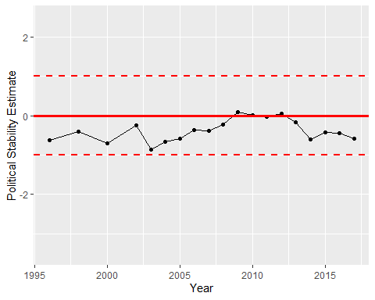

Political Stability Trend